Youth Project Framework for Students with IDD and Autism

Overview
The Youth Project aims to empower students with intellectual and developmental disabilities (IDD) and Autism by providing them with self-advocacy tools, identifying their learning styles, and exploring post-secondary pathways in college, entrepreneurship, vocational, and trade programs. The program ensures students from diverse backgrounds and family supports receive equitable opportunities for success.

Organizational Roles & Responsibilities
- Special Education (SPED) Teacher: Supports middle school students with accommodations, learning strategies, and social-emotional development.
- Supplemental High School Program: Prepares students for workforce development and career readiness, providing resources on accommodations and accessibility.
- Nonprofit Organization: Recruits students outside of the school setting, offers mentorship, and connects students to community partnerships.

Project Timeline & Phases

Phase 1: Planning & Development (1-2 Months Before Launch)
- Define program goals and outcomes.
- Establish collaboration among key organizations.
- Develop a curriculum covering self-advocacy, accommodations, career exploration, and communication strategies.
- Secure funding, partnerships, and resources for program implementation.
- Identify assistive technology tools and support systems.

Phase 2: Student Recruitment & Onboarding (1-2 Months Before Launch, Ongoing)
- Outreach via middle schools, high schools, and community organizations.
- Establish student recruitment and onboarding workflow
- Application and intake process, including needs assessments and baseline evaluations.
- Orientation sessions for students and families to introduce program expectations and resources.

Phase 3: Program Implementation (up to 12 Weeks)

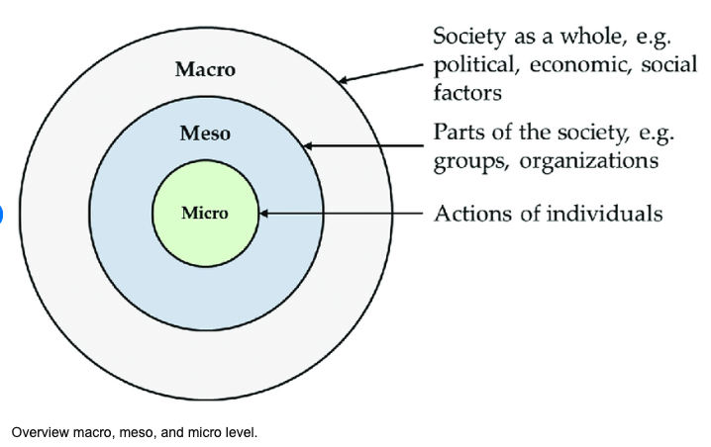

Self-Advocacy
- Learning Accommodations
- Understanding IEPs, 504 Plans, and requesting accommodations (tools for the toolbelt).
- Verbal and non-verbal communication techniques for self-expression.

Education & Career Pathways
- College readiness workshops (applications, financial aid, accessibility services).
- Vocational and trade program exploration through site visits and hands-on training.
- Entrepreneurship training in creative arts and technology-based businesses.

Social-Emotional Learning & Community Engagement
- Peer mentorship and group discussions.
- Real-world role-playing (job interviews, college life, professional settings).
- Parent and family engagement workshops.

Phase 4: Transition Planning & Ongoing Support (Final 4 Weeks & Beyond)
- Individualized Transition Plans outlining next steps (college, employment, independent living).
- Connection to transition coordinators, job coaches, and disability support services.
- Development of an alumni mentorship network for continued guidance and community involvement.
- Program evaluation through surveys, outcome tracking, and strategy refinement for future cohorts.

Making This Framework Accessible for All Learning Styles
To ensure all students understand and engage with the program, we incorporate:
- Visual Learners: Infographics, flowcharts, and illustrated guides explaining each step.
- Auditory Learners: Group discussions, recorded audio explanations, and peer mentorship.
- Kinesthetic Learners: Hands-on activities, role-playing, and interactive workshops.
- Reading/Writing Learners: Clear written guides, note-taking supports, and reflection journals.
Resource:
https://livestreamlearningstudio.com/blog/teaching-learning-styles-and-accommodating-to-them/
Additionally, we provide assistive technology for non-verbal students, allowing them to express themselves using communication boards, speech-to-text tools, and adaptive software.

Sustainability & Growth
To ensure long-term success, the project will:
- Expand partnerships with advocacy groups, employers, and higher education institutions.
- Apply for grants and sponsorships to fund additional resources and scaling.
- Create student-led initiatives to promote self-advocacy and disability awareness in the broader community.
Conclusion: This framework provides a structured approach to supporting students with IDD and Autism, equipping them with essential life skills, educational pathways, and self-advocacy tools. The collaboration between educators, supplemental programs, and nonprofits ensures a holistic approach to student success beyond the classroom.

